**IoT: Smart Home Sensing on SDN network**

|  |  |  |
| --- | --- | --- |
| Hiu Hong Yu  Department of Computer Science  University of California, Davis  Email: hiuyu@ucdavis.edu | Josiah Jee  Department of Computer Science  University of California, Davis  Email: jjee@ucdavis.edu | Francesco Capponi  Department of Computer Science  University of California, Davis  Email: capponi.francesco@gmail.com |

1. INTRODUCTION AND ABSTRACT

Smart home application had recently becoming a hot topic for Internet of Things (IoT). For example, Honda smart home energy management system [1], where user can monitor their home energy usage over the internet, and perform associate action to adjust. However, in reality, there are much more smart home applications than what we can think of, such as detect leakage from water pipe, which require an uncountable amount of hardware for detection if we wanted to cover all.

With amount of different smart home sensing/detection applications on the market today, each with it own detection and decision hardware. The cost of a fully equipped smart home is unimaginable. The goal of this project is to reduce hardware and energy cost [2], decision delay, improve reaction speed for emergency situation, and possibly reduce human interaction by applying Software-defined Network (SDN) to IoT application.

1. PROBLEM

From the above discussion, the following question arise:

1. How will SDN reduce hardware and energy cost?
2. How to improve reaction speed?
3. How to reduce delay?
4. How many sensors are required?
5. How much modification do we need to support all the above?
6. PROPOSAL
7. SDN Reduce Hardware and Energy Cost

A true smart home consists of many sensors and decision device, each required a processor for decision making, and energy source (we use energy as a measure because energy include the time constant while power doesn’t, smart home applications are turned on 24/7). By applying the concept of SDN, where decision making is done in a centralized controller, which reduce the amount of processors required by each sensing modules. While processors amount reduces, energy requirements are also reduced. Computation will be required only when sensor detected something. See Figure 1 for possible smart home setup.

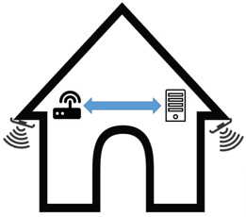

Figure 1: Smart Home Sensing System

1. Reducing Delay and Improve Associate Reaction Speed

With N devices on the network, such as the Net Camera [3], where each device requires an IP address. It put a lot of pressure to IP layer as more devices are installed. However, with individual decision making, there is a possible chance where all sensors in the house will be turned on and require immediate action at the same time, which results in network congestion. The services which require real immediate action are not prioritized in case of network congestion.

With SDN, all data will be sent to centralized controller for decision making. The controller decides which services/data must be prioritized.

1. Amount of Sensors Required

With the SDN implementation, the amount of sensors can be arbitrary, since additional hardware is not required while setting up the network. Each sensing devices will be connected wirelessly and directly to the centralized controller (Also reduced pressure from IP layer, as devices does not require an IP), while devices, such as emergency water shut down, will be connected through the network with the controller. Figure 2 shows a visual setup of the implementation.

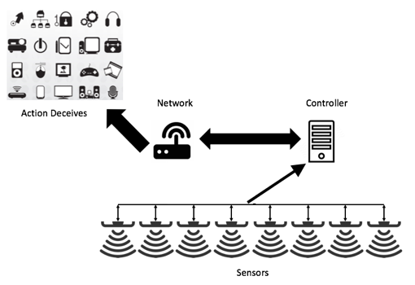

Figure 2: IoT Sensing Network with SDN

**Note: Due to budget problem, our study will not connect sensors directly to the controller, but instead through a router.**

1. Modifications Required

Modifications of the existing product is minimal, since IoT and SDN are both relatively new topic to the public. As of 2014, there are 21 million household equipped at least one smart home devices [4], which this is 0.18% of the total US household [5]. With SDN implementation, existing applications can be easily converted to our approach by simple adapter.

1. REFERENCE

# Andy Fell (3/25/2014). Honda Smart Home at UC Davis West Village offers vision for zero carbon living. UC Davis. https://www.ucdavis.edu/news/honda-smart-home-uc-davis-west-village-offers-vision-zero-carbon-living

1. David Geer (1/2015). SDN to support Internet of Things devices. IoTAgenda. http://internetofthingsagenda.techtarget.com/feature/SDN-to-support-Internet-of-Things-devices
2. Netcam, Belkin. http://www.belkin.com/us/F7D7606-RM-Belkin/p/P-F7D7606-RM;jsessionid=9852486C04A9B0C259042303940A1423/
3. William Ablondi | Jul 16, 2014 US lead Smart Home Adoption Globally. https://www.strategyanalytics.com/strategy-analytics/news/strategy-analytics-press-releases/strategy-analytics-press-release/2014/12/09/us-leads-smart-home-adoption-globally#.VqQZ0FMrKHo
4. Statistic brain research institute (10/3/2014). Total Number of US Households. Statistic brain research institute. http://www.statisticbrain.com/u-s-household-statistics/